|  |
| --- |
| K1415709 |
| Technical Lead - Hackney Pirates AR Children’s Book |
| CI7810 Digital Studio Practice |
| Figure 1: Functioning AR book |
| **Greene, Philip** |
| **K1415709** |

<https://kingston.box.com/s/mov0iw5jux41ldbi8e5j0l8nh4zeq8v9>

|  |
| --- |
|  |

Table of Contents

Introduction 2

Project/Game Overview 2

Role Outline 2

Programming Teamwork 2

Technologies 3

AR Platforms 3

Implementation 5

Tasks implemented by technical lead: 5

Functionality 6

Maze 6

Donut Factory 7

Coconut shooting 8

Spear fishing 10

Penguin game 11

Combination lock puzzle 13

Conclusions 14

References 15

# Introduction

## Project/Game Overview

Developed for android the ‘Hackney Pirates’ activity book is an augmented reality experience that coupled with the ‘The Hackney Atlas’ book written by the young pirates (members of the charity) aims to bring the children’s stories to life in a fun and engaging way.

The activity book is broken down into five chapters consisting of a planned total of ten games of which as of writing seven have been implemented. This is accompanied by a quiz and treasure chest that is unlocked by answering a question correctly on each chapter.

## Role Outline

For this project I took on the role of technical/programming lead so was responsible for deciding on which technology would be used to create the AR book and through working with the other programmer on our team; implement the variety of games/elements that the book has to offer.

## Programming Teamwork

To manage the work with the other programmer unity collaboration was used as version control. This ensured that we could work simultaneously and if any serious problems occurred the project could be restored to an older version.

However, an issue when using unity collaboration is that problems are likely to occur when two or more people are working in a single scene therefore to organise the work we would work on different pages of the book each in their own scene. When nearing completion, we would then compile both of our work into a single scene ready for release this avoids the problem of stepping on each other’s toes when using collaborate.

If either of us needed help from the other or to solve tasks that neither of us were sure how to solve we would use the agile technique of pair programming which involves two programmers working on a single machine. This ensures that our productivity does not stagnate if either of us got stuck.

# Technologies

It was decided very early on that the book would be developed using the Unity game engine as this was what our programmers had the most experience working with as well as offering support for AR with the ability to build for mobile.

Android was chosen as the OS to build to as it is free to publish and the most popular with many devices including cheaper hardware running android making it much more accessible when compared to IOS and other operating systems.

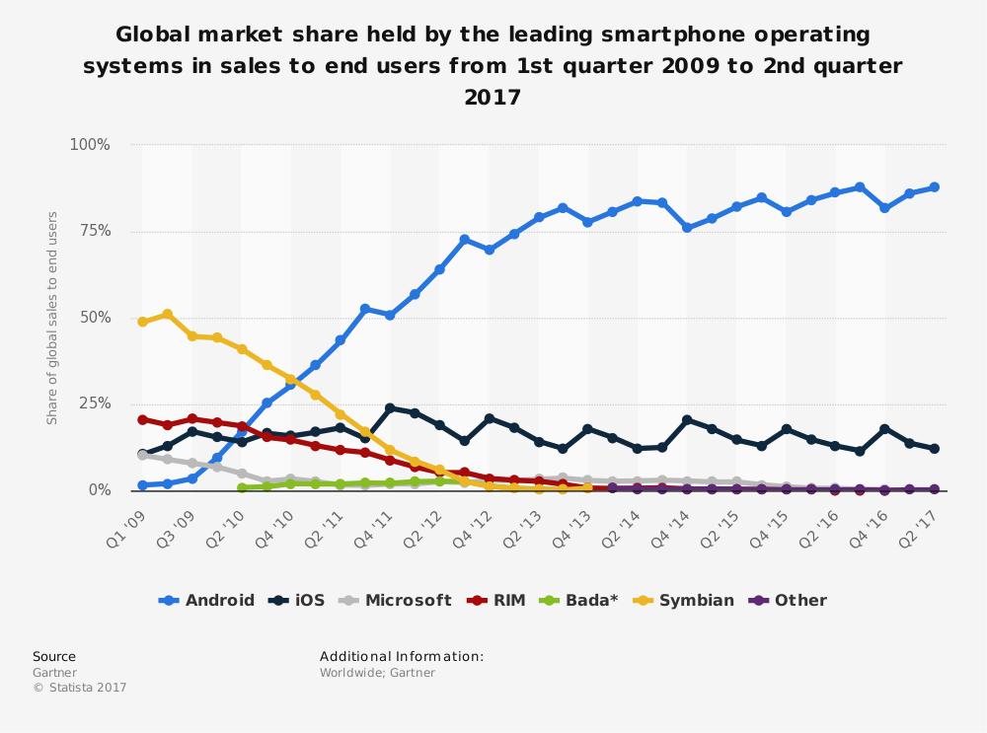

Figure 2: Global market share of mobile OS

Android holds over 75% of the global market share when compared to other operating systems.

## AR Platforms

For developing the book there are a variety of different augmented reality platforms to choose from, some of the most popular platforms include:

* BlippAR
* Vuforia
* ARKit
* ARCore

BlippAR wasn’t suitable as this doesn’t have integration with unity utilising its own engine Blippbuilder which uses a JavaScript scripting interface.

ARKit is apple’s framework for developing augmented reality apps and includes integration with unity however it cannot be used to develop for android.

The two most suitable platforms include ARCore and Vuforia as both fulfil the requirements needed to develop the book and can be used with unity to develop for android.

Vuforia was chosen over ARCore as our programmers have previous experience using this platform. Vuforia can also be installed directly with the unity editor as of version 2017.2.0f3 therefore does not require the downloading any additional SDKs meaning it is better supported being a partner of unity.

# Implementation

## Tasks implemented by technical lead:

* Objects being visible in augmented reality using image targets
* Movement
  + Maze/Donut game
    - Rigid bodies can be moved by tilting the physical page by adding forces
  + Penguin game
    - The player can tap on the screen to move the penguin to the desired location
* Shooting
  + Launch projectiles from the AR camera’s position
  + Coconut game
    - Shoot at moving targets
  + Fishing game
    - Shoot at moving fish
* Combination lock puzzle
  + The player spins each lock cylinder to the correct location to open the chest
* Collision detection
  + Collisions between the coconuts and targets, spear and fish and the player and coins
* Timing/Score
  + The player is given a limited amount of time to score as high as possible
* Animations
  + Implementing work made by our animator

## Functionality

### Maze

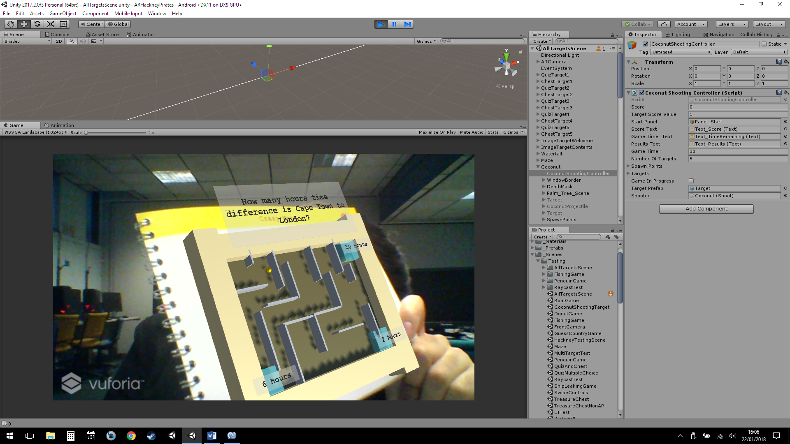

Figure 3: Completed maze game

The objective of the maze game is to move the ball to the correct answer this is done by tilting the page in the appropriate direction.

    void FixedUpdate () {  
        if (MazeController.isMaze && gameInProgress) { *// The AR Camera is focused on the maze target and the game has started*  
            ballObject.GetComponent<Rigidbody>().AddForce (ARCameraTransform.forward * thrust);  
            ballObject.GetComponent<Rigidbody>().isKinematic = false;  
        } else {  
            ballObject.GetComponent<Rigidbody>().isKinematic = true;  
        }  
    }

This is implemented by adding a force to the ball based on the forward vector of the camera relative to the ball.

Once the player reaches an answer they are told whether they answered correctly and an option to generate a new question is given. These questions and answers are read from a text file.

### Donut Factory

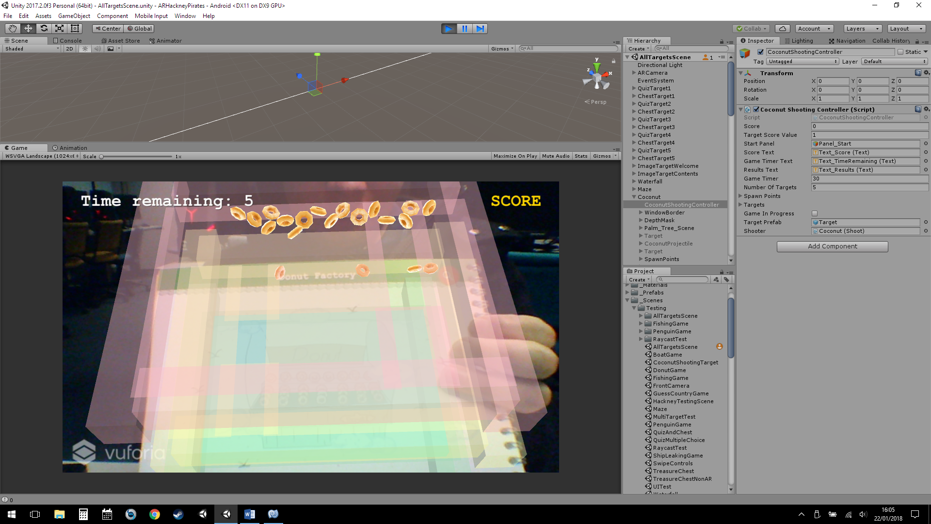

Figure 4: Donut game gameplay

The objective of the donut game is to move donuts from the top of the building to the bottom through the holes on each floor by tilting the page. The player is given 30 seconds to get as many donuts as they can to the bottom as possible.

    private void Update()  
    {  
        if (dgc.gameInProgress && Time.time > nextSpawn && donutCount < maxNumberOfDonuts && DonutGameController.isDonutGame)  
        {  
            nextSpawn = Time.time + spawnRate;  
            donutCount++;  
  
            GameObject donutObject = Instantiate(donutPrefab, transform);  
            donutObject.transform.parent = transform;  
            donutObject.transform.position = transform.position;  
            donutObject.transform.rotation = transform.rotation;  
        }  
    }

Donuts are instantiated every second at the top of the building by the DonutSpawn class until the max number of donuts is increased. This ensures that the number of objects the player has control over is manageable.

Once the donuts reach the bottom they are destroyed and the score is increased. This in turn decreases the overall count of the donuts spawned resulting in more donuts being spawned at the top.

### Coconut shooting

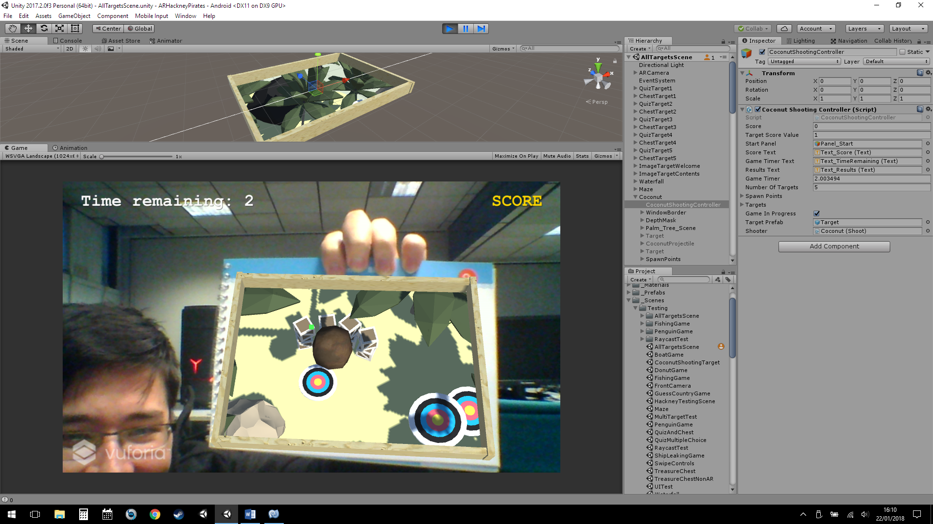

Figure 5: Completed coconut shooting game

For the coconut game the player aims to hit as many targets as possible within a given time. To shoot the player taps on the screen to instantiate a coconut from the AR camera’s position. The coconut object is a rigid body so a force is applied once it has been instantiated.

    private void SpawnTargets()  
    {  
        List<int> randomIntList = new List<int>();  
  
        *// Spawn targets at random pre determined spots ensuring no targets spawn on top of each other*  
        for (int i = 0; i < numberOfTargets; i++)   
        {  
            int randomNumber = Random.Range(0, spawnPoints.Length);  
  
            while (randomIntList.Contains(randomNumber))  
            {  
                randomNumber = Random.Range(0, spawnPoints.Length);  
            }  
  
            randomIntList.Add(randomNumber);  
  
            *// Spawn target at random position*  
            GameObject targetObject = Instantiate(targetPrefab, transform.parent);  
            targetObject.transform.position = spawnPoints[randomNumber].position;  
            targetObject.GetComponent<Target>().moveSpeed = Random.Range(-2, 2);  
            targets.Add(targetObject.GetComponent<Target>());  
        }  
    }

At the start of the game several targets are spawned at random predetermined locations. To ensure that targets do not spawn at the same position a list is used to store each spawn number as each target is spawned. A new spawn number is generated if it is already being used by a previously spawned target.

This spawn number is then used to determine the position of the target.

targetObject.transform.position = spawnPoints[randomNumber].position;

#### Window effect

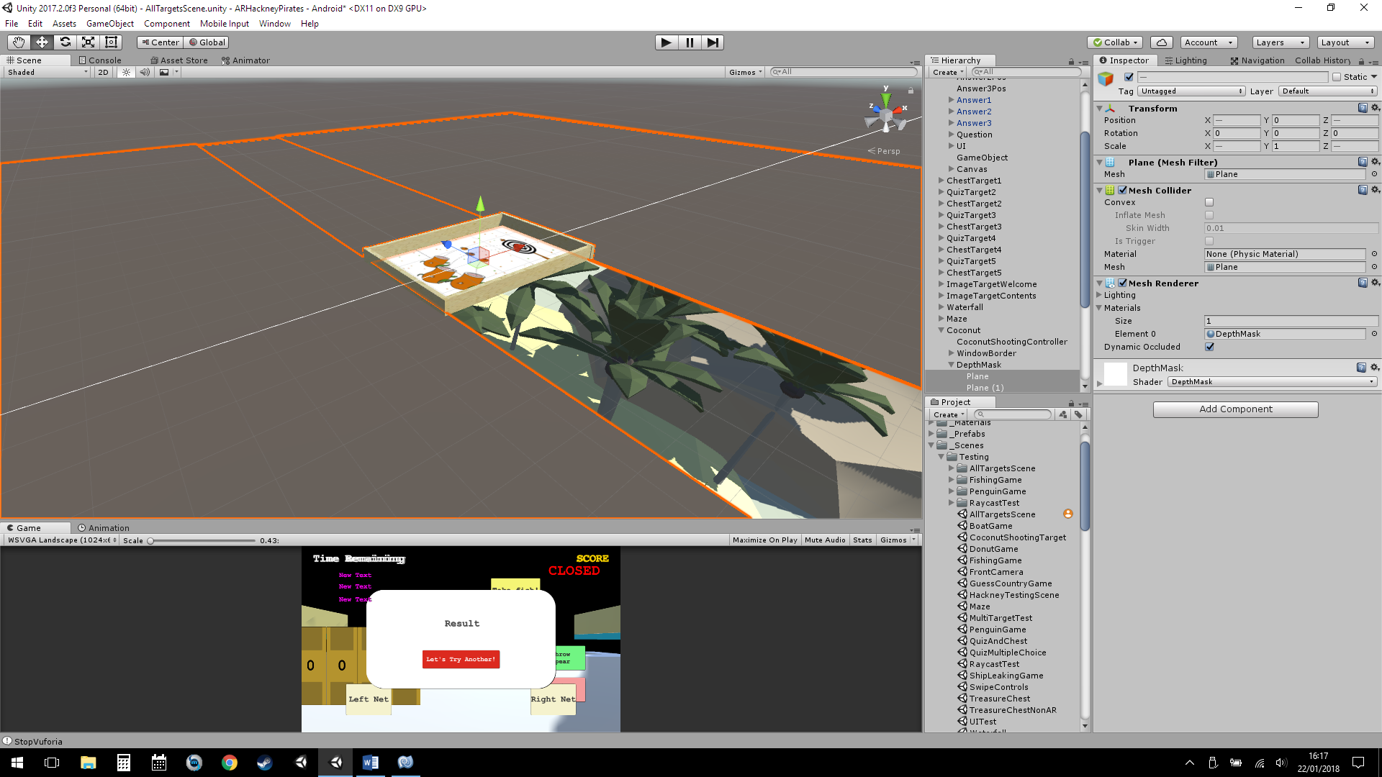

Figure 6: Depth masks surrounding the image target (One removed for demonstration)

To create the effect that objects appear inside the page when viewed in AR. A depth mask is placed around the image target which hides the objects below. This makes it so that these objects can only be viewed through the target image.

In the figure above one of the depth masks has been removed to show the objects underneath.

### Spear fishing

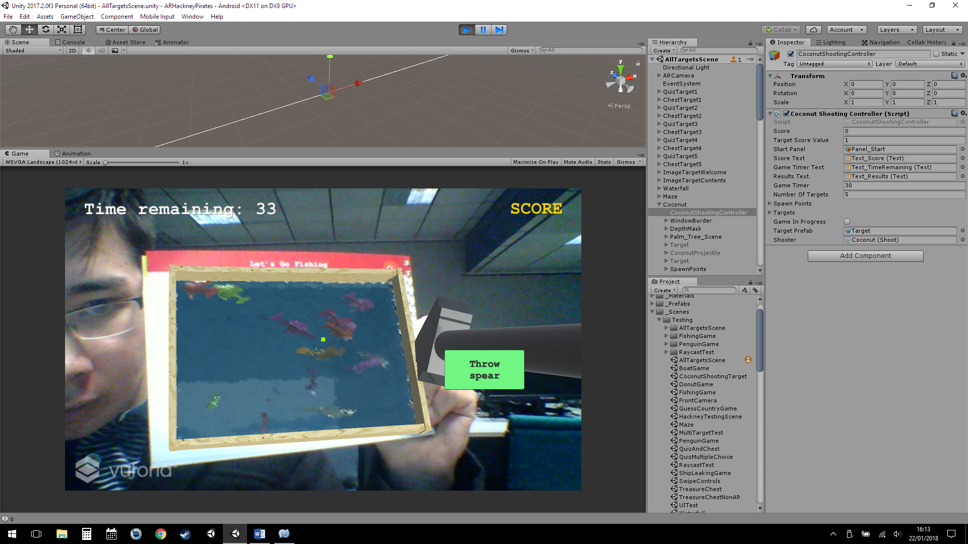

Figure 7: Completed fishing game

Similar to the coconut game the player throws spears into the water below in an attempt to catch fish. Once the spear has been thrown it can then be retrieved. If the spear has hit a fish it can then be collected (after the spear has been retrieved).

For the schooling movement of the fish a boid flocking algorithm was used based on sample work in class. This created more realistic movement for the fish as they would move in a group rather than move in random directions.

To create the interaction between the spear and the fish it was broken down into several parts:

**First** the spear checks for a collision with a fish

**Second** the fish’s schooling behaviour is disabled

**Third** the fish is parented to the spear object, so they would move together.

    private void CatchFish()  
    {  
        caughtFishObject.GetComponent<Boid>().enabled = false; *// Schooling/Flocking behaviour is disabled*  
        caughtFishObject.GetComponent<Rigidbody>().isKinematic = true; *// Disable physics*  
  
        *// Move the fish onto the spear and parent it*  
        caughtFishObject.transform.position = caughtPosition.transform.position;  
        caughtFishObject.transform.parent = caughtPosition.transform;  
  
        *// Set the rotation of the fish*  
        Quaternion temp = caughtFishObject.transform.rotation;  
        temp.eulerAngles = new Vector3(0f, 90f, 0f);  
        caughtFishObject.transform.rotation = temp;   
    }

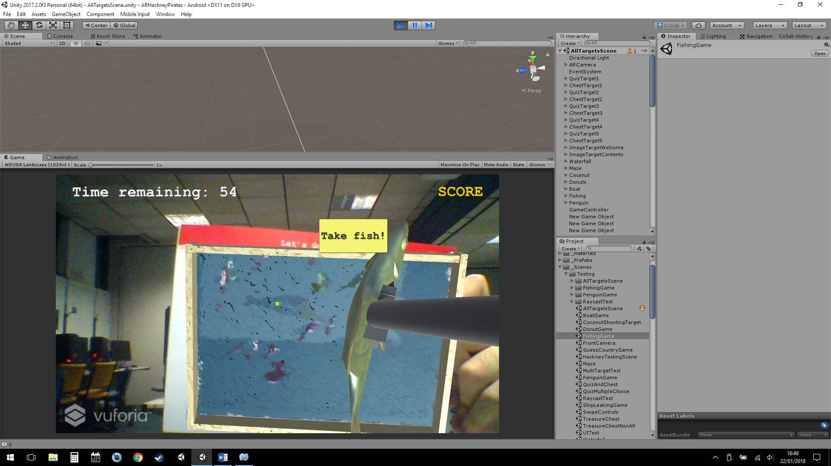

Figure 8: The player catching a fish

### Penguin game

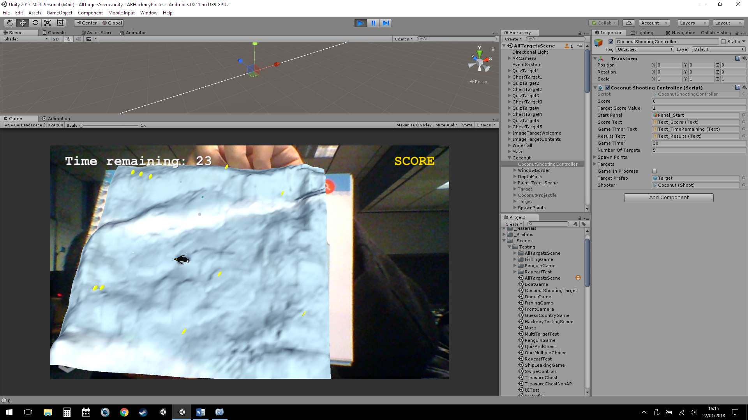

Figure 9: Completed penguin game

The objective of the penguin game is to collect as many coins as possible through moving the penguin around the terrain by tapping on the screen.

The penguin moves around on a navigation mesh baked onto the terrain. The location the penguin moves to, on the terrain is based on the location the user’s touch.

To create this game what first needed to be implemented was the ability to detect touches onto the screen and use those to determine a location for the penguin to move.

This was achieved by ray casting from the screen to world space. Where the ray collides with the terrain it can be assumed that this is the desired location for the penguin. The penguin then moves along the terrain through the navigation mesh to reach this location.

        for (int i = 0; i < Input.touchCount; i++) *// The player is touching the screen*  
        {  
            if (Input.GetTouch(i).phase == TouchPhase.Began)   
            {                  
                ray = Camera.main.ScreenPointToRay(Input.GetTouch(i).position);  
  
                if (Physics.Raycast(ray, out hit, 100, layerMask))   
                {  
                    navMeshAgent.SetDestination(hit.point); *// Move the penguin to the hit location*  
                }  
            }  
        }

To spawn the coins random positions on the terrain were taken from each edge and then the terrain height needed to be sampled ensure that the coin was spawned above the terrain.

    public void SpawnCoin()  
    {  
        *// Spawn coins at a random position on the terrain then move them up to match the terrain height at that position*  
        float posX = Random.Range(terrain.transform.position.x, terrain.transform.position.x + terrain.terrainData.size.x);  
        float posZ = Random.Range(terrain.transform.position.z, terrain.transform.position.z + terrain.terrainData.size.z);  
        float posY = terrain.SampleHeight(new Vector3(posX, 0, posZ));  
        Vector3 spawnPosition = new Vector3(posX, posY, posZ);  
  
        GameObject coinObject = Instantiate(coinPrefab);  
        coinObject.transform.parent = transform;  
        coinObject.transform.position = spawnPosition;  
        coinObject.GetComponent<Rigidbody>().useGravity = false;  
    }

### Combination lock puzzle

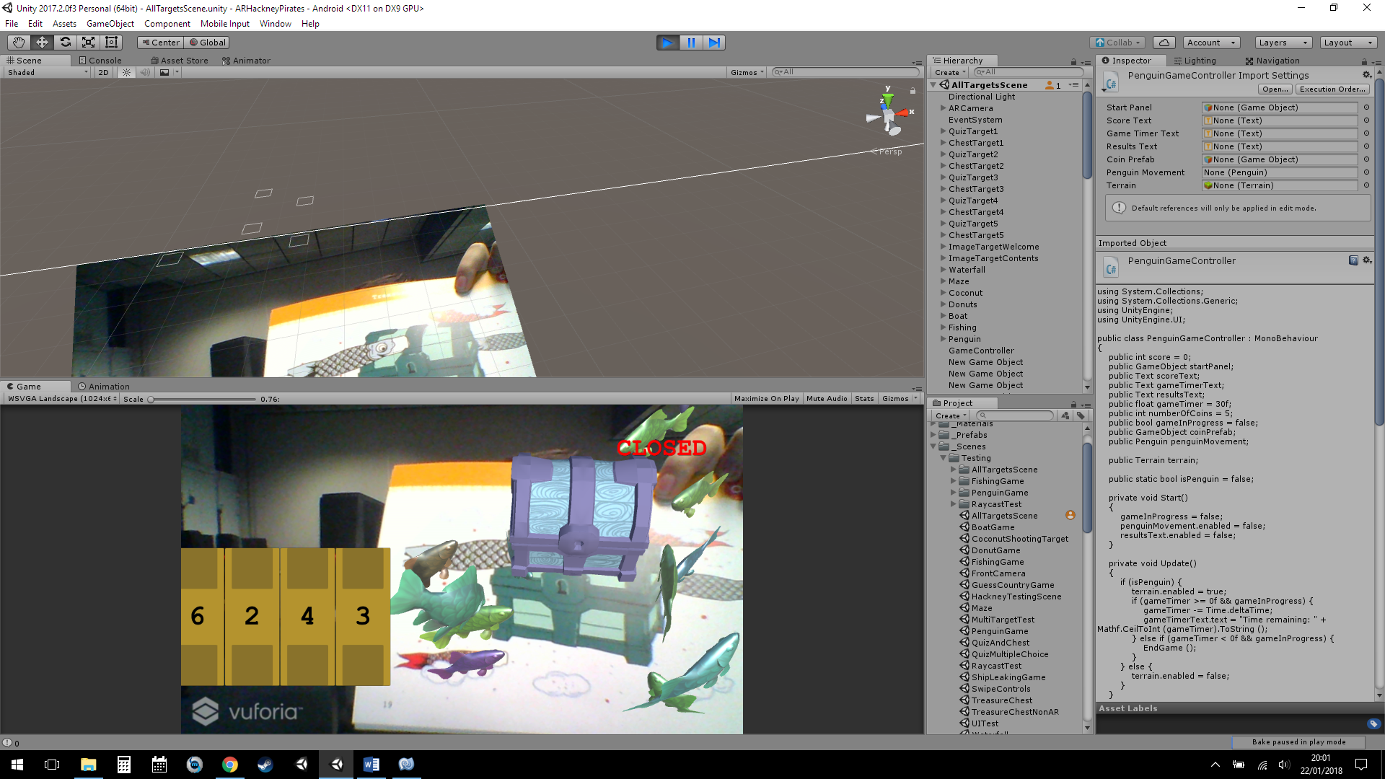

Figure 10: Completed combination lock

To unlock the chest the user needs to input the correct combination. This combination can be found by answering questions correctly. Each chapter features its own separate quiz and chest with the appropriate quiz providing the combination to its relevant chest.

To break the game down each number on the screen contained the number panel script which controls increasing or decreasing the number for that lock cylinder.

The lock controller script would generate the lock solution and manage each number panel for use when checking each panel to the solution.

At the start of the game the lock solution is randomised to ensure that players cannot use the same combination each playthrough.

The lock solution was stored as a string, a string being an array of chars meaning each element in the string could be checked against the current combination on screen.

    void Start () {  
  
        numberPanels = GetComponentsInChildren<NumberPanel> ();  
  
        for (int i = 0; i < numberPanels.Length; i++) {  
            int randomNum = Random.Range (0, 10);  
            lockSolution += randomNum.ToString ();  
        }  
  
        lockSolutionText.text = lockSolution;  
    }  
  
    public void CheckCombination () {  
        for (int i = 0; i < numberPanels.Length; i++) {  
            if (numberPanels [i].currentNumber.ToString() != lockSolution [i].ToString()) {  
                CloseLock ();  
                return;  
            }  
        }  
        OpenLock ();  
    }

When the player sets each panel to match the solution the chest is opened. Otherwise the chest remains locked or is set a locked state from an open one.

# Conclusions

This project has given me the opportunity to learn and develop meaningful augmented reality experiences by having the Hackney Pirates as a client for our team’s work. By having a client gave our team a common goal to work towards as well as providing us invaluable feedback to create the best app possible.

Due to the projects varied nature I have learnt multiple ways of implementing AR in interesting ways to create games which has benefited me greatly. The downside of having a varied project is that a mechanic is only explored at mostly a surface level whilst focusing on one mechanic or feature and expanding on that would have potentially yielded more polished results.

Our teams project was very ambitious with the original plan incorporating ten different games as well as a selfie and scoring leader board system. These are elements I wish to complete in future for the sake of my learning as well as the client. Though considering the time given our team has performed extremely well.

This project being developed for augmented reality means that it is very relevant providing a solid foundation for what is to come as AR technology is currently being innovated even further with newer hardware featuring multiple cameras to detect depth sensing and new mixed reality experiences incorporating both augmented and virtual reality elements.

# References

VersionOne. (2018). *Pair Programming: Agile Programming Practices*. [online] Available at: https://www.versionone.com/agile-101/agile-software-programming-best-practices/pair-programming/ [Accessed 22 Jan. 2018].

Statista. (2017). *Mobile OS market share 2017 | Statista*. [online] Available at: https://www.statista.com/statistics/266136/global-market-share-held-by-smartphone-operating-systems [Accessed 22 Jan. 2018].

Developer.apple.com. (2018). *ARKit | Apple Developer Documentation*. [online] Available at: https://developer.apple.com/documentation/arkit?language=objc [Accessed 22 Jan. 2018].

Google Developers. (2018). *ARCore - Google Developer  |  ARCore  |  Google Developers*. [online] Available at: https://developers.google.com/ar/ [Accessed 22 Jan. 2018].

Unity. (2018). *Unity - Partners - Vuforia*. [online] Available at: https://unity3d.com/partners/vuforia [Accessed 22 Jan. 2018].

Web.blippar.com. (2018). *Create & Make Augmented Reality Using Blippbuilder Tools | BlipparWebsite*. [online] Available at: https://web.blippar.com/blipp-builder [Accessed 22 Jan. 2018].